Analyzing the heart with EKG Name Luke David Jared
Group Names
Table 1
Interval | Time(s) | Heart Rate( bpm) | 134
P-R | 0.09
QRS | 0.08
Q-T | 0.47
R-R | 0.75
Table 2 Standard Resting Electrocardiogram Interval Times
P-R interval | 0.12 to .20 s
QRS interval | Less than 0.12
Q-T interval | 0.3-0.4 s
Graphs with Descriptions

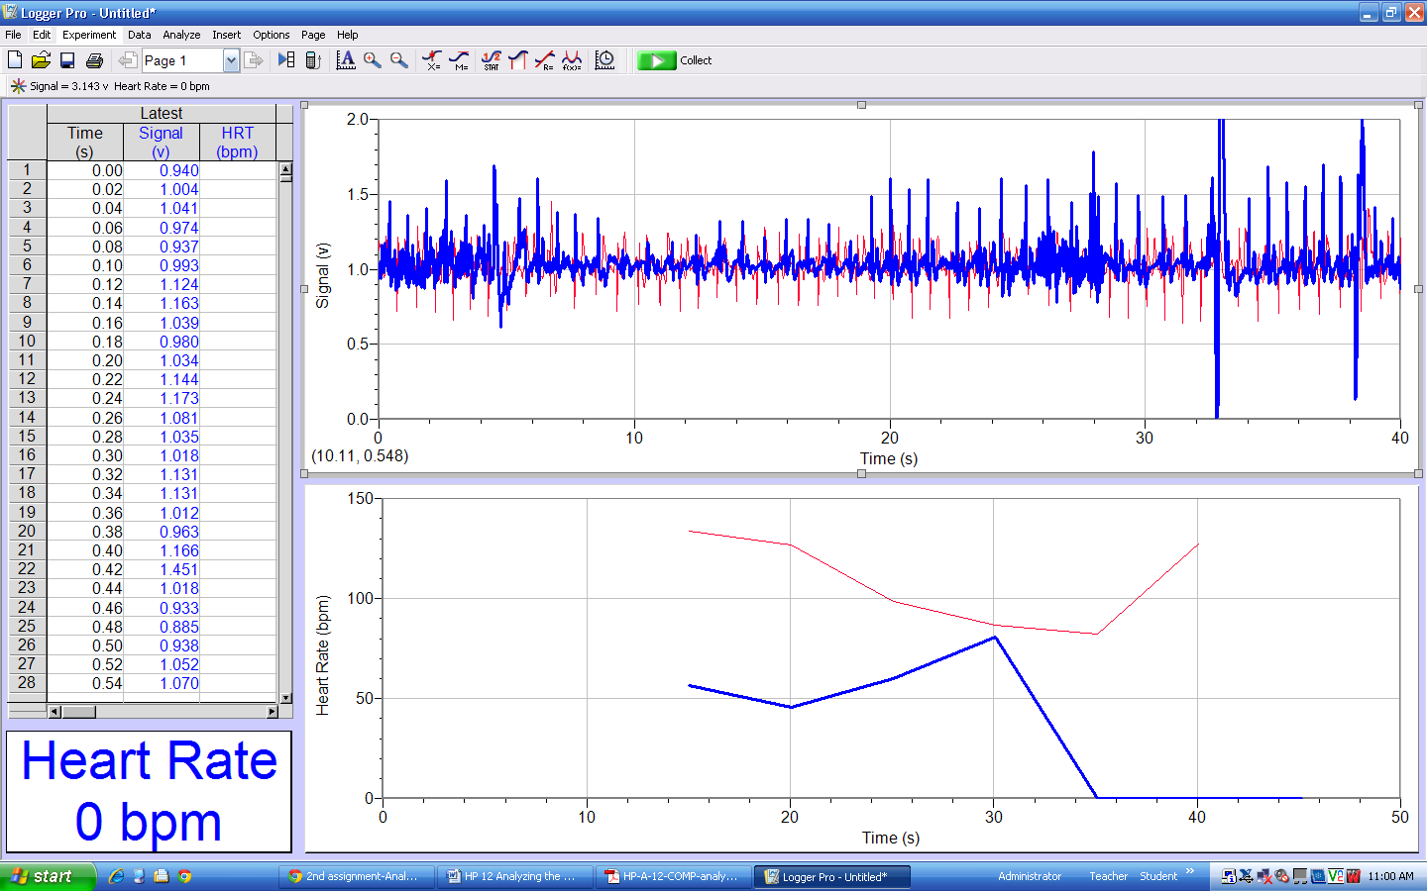

Data Analysis
- Remember that a positive deflection indicates electrical activity moving toward the green
EKG lead. Examine the two major deflections of a single QRS complex (R wave and S
wave) in your EKG tracing from Part I of this experiment. According to this data, does
ventricular depolarization proceed from right to left or left to right? How does your tracing
from Part II confirm your answer?
Ventricular depolarization proceeds from left to right. The graph from part II is inverted of what the graph from part I was. The depolarization begins in the right atrium and proceeds to the left and right ventricle. Because the left ventricle wall is thicker than the right wall, the arrow indicating the direction of the depolarization wave is directed to the left.
- Health-care professionals ask the following questions when interpreting an EKG:
Can all components be identified in each beat?
Are the intervals between each component and each complex consistent?
Are there clear abnormalities of any of the wave components?
Using these questions as guides, analyze each of the following three-beat EKG tracings and
record your conclusions in Table 3 (indicate presence or absence of the P wave, and whether
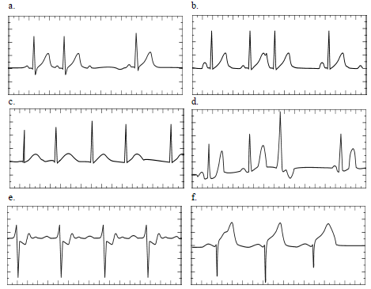
other intervals and/or shapes are normal or abnormal). The first analysis (a) is done for you.

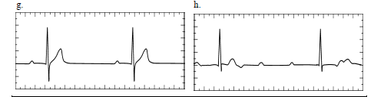

 |  |  | P Wave |  | PR interval |  |  | QRS Interval |  | QRS Shape |  | TWave Shape
ECG |  | Beats | Pres. | Abs. | Nml | Abs./Abn |  | Nml | Abs./Abl | Nml | Abn. | Nml | Abs./Abn.
a |  | 1 | X |  | X |  | X |  |  | X |  | X
 |  | 2 | X |  | X |  | X |  |  | X |  | X
 |  | 3 | X |  |  | X |  |  | X |  | X |  | X
b |  | 1 | X |  | X |  | X |  |  |  | X | X
 |  | 2 | X |  | X |  | X |  |  |  | X | X
 |  | 3 | X |  |  | X | X |  |  |  | X | X
c |  | 1 |  | X |  | X | X |  |  |  | X | X
 |  | 2 |  | X |  | X | X |  |  |  | X | X
 |  | 3 |  | X |  | X | X |  |  |  | X | X
d |  | 1 | X |  |  | X | X |  |  |  | X | X
 |  | 2 | X |  | X |  | X |  |  |  | X | X
 |  | 3 |  | X |  | X | X |  |  |  | X |  | X
e |  | 1 |  | X |  | X | X |  |  |  | X | X
 |  | 2 | X |  | X |  | X |  |  |  | X | X
 |  | 3 | X |  | X |  | X |  |  |  | X | X
f |  | 1 | X |  | X |  | X |  |  |  | X | X
 |  | 2 | X |  | X |  | X |  |  |  | X | X
 |  | 3 | X |  | X |  | X |  |  |  | X | X
g |  | 1 | X |  | X |  | X |  |  | X |  | X
 |  | 2 | X |  | X |  | X |  |  | X |  | X
 |  | 3 | - | - | - | - | - |  | - | - | - | - | -
h |  | 1 | X |  | X |  | X |  |  |  | X | X
 |  | 2 | X |  | X |  | X |  |  |  | X |  | X
 |  | 3 | - | - | - | - | - |  | - | - | - | - | -

