Flow Design
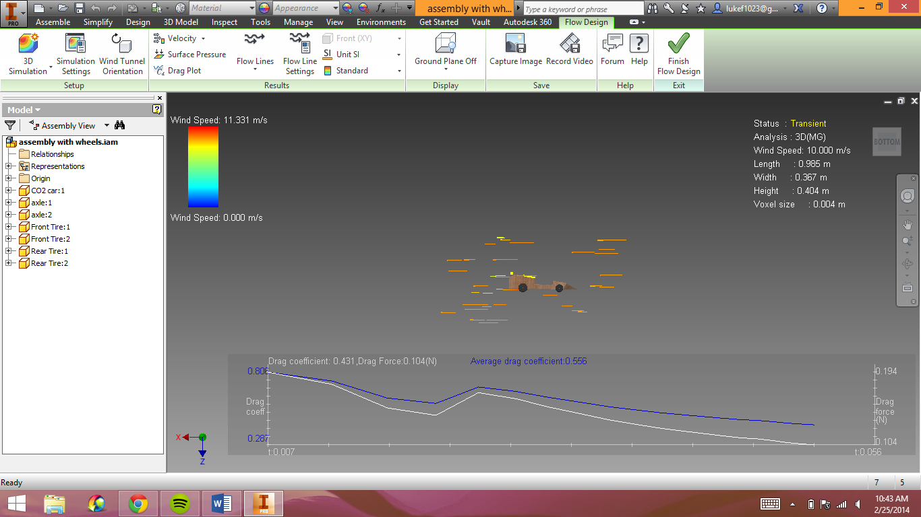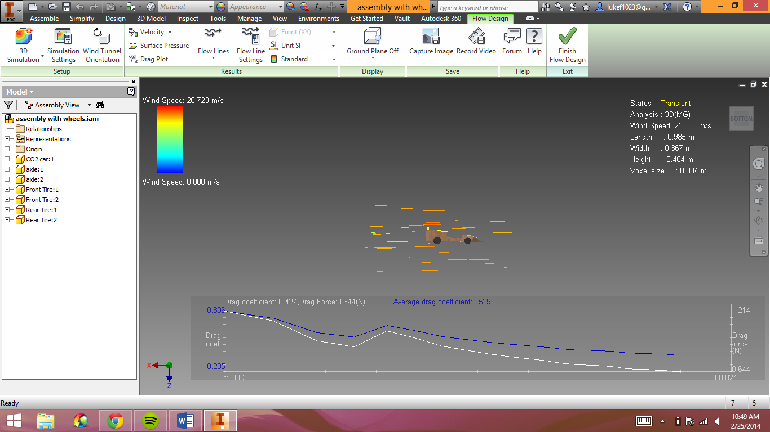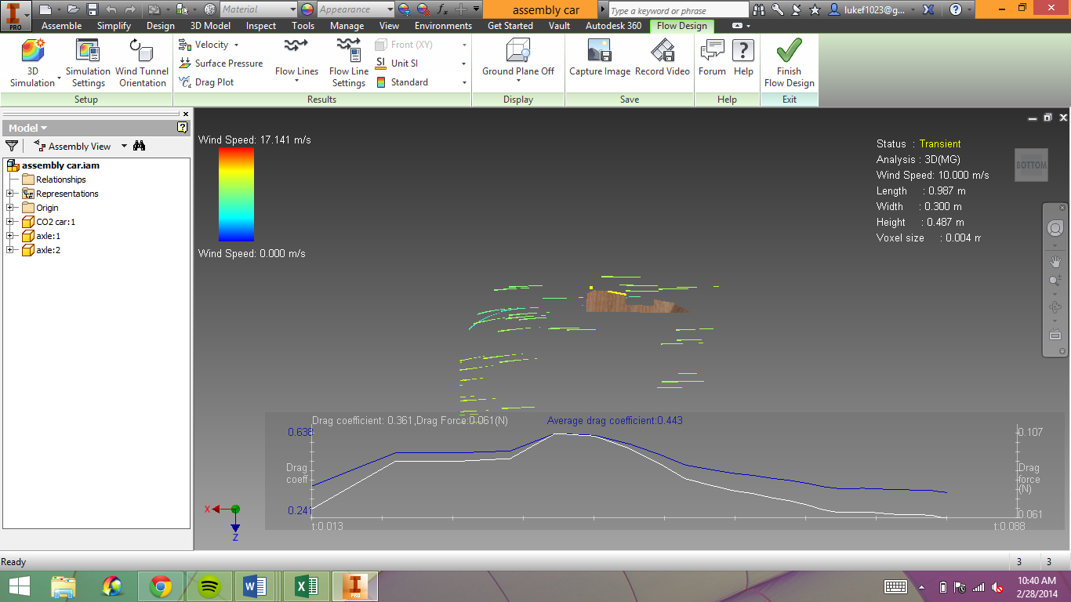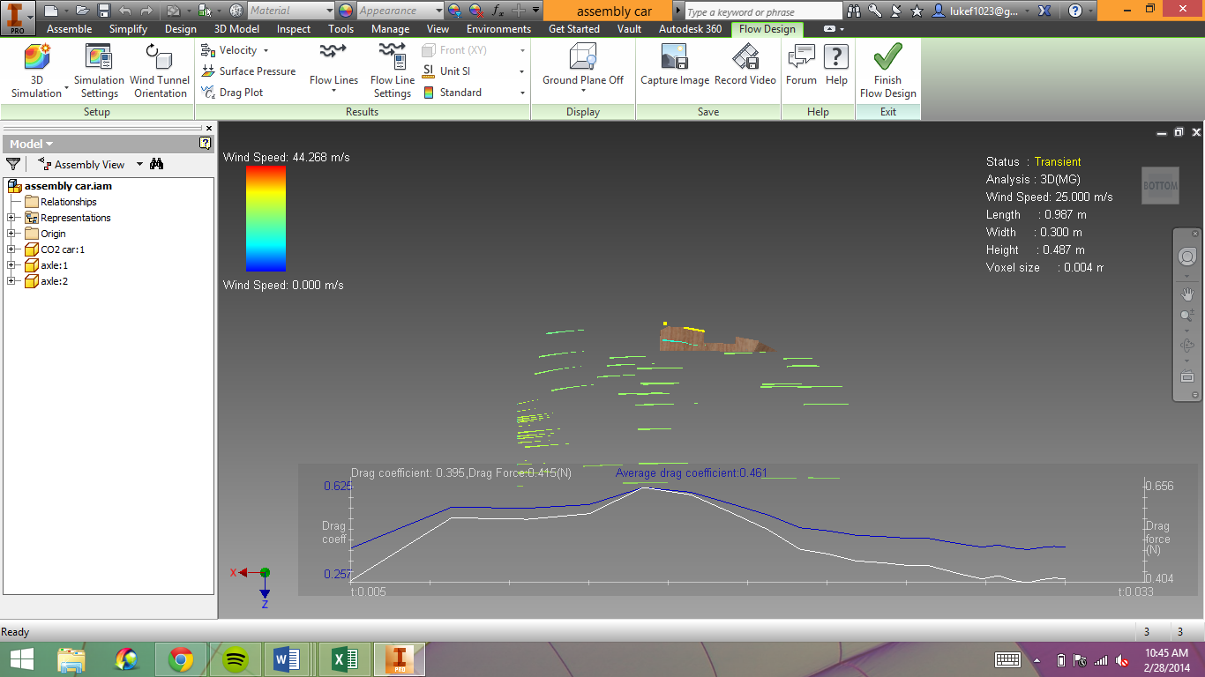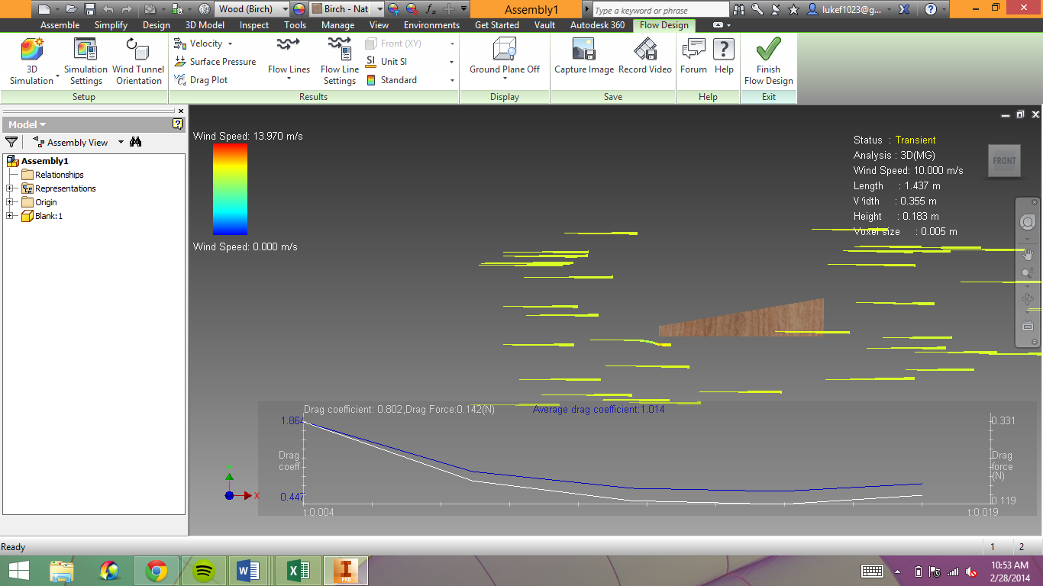

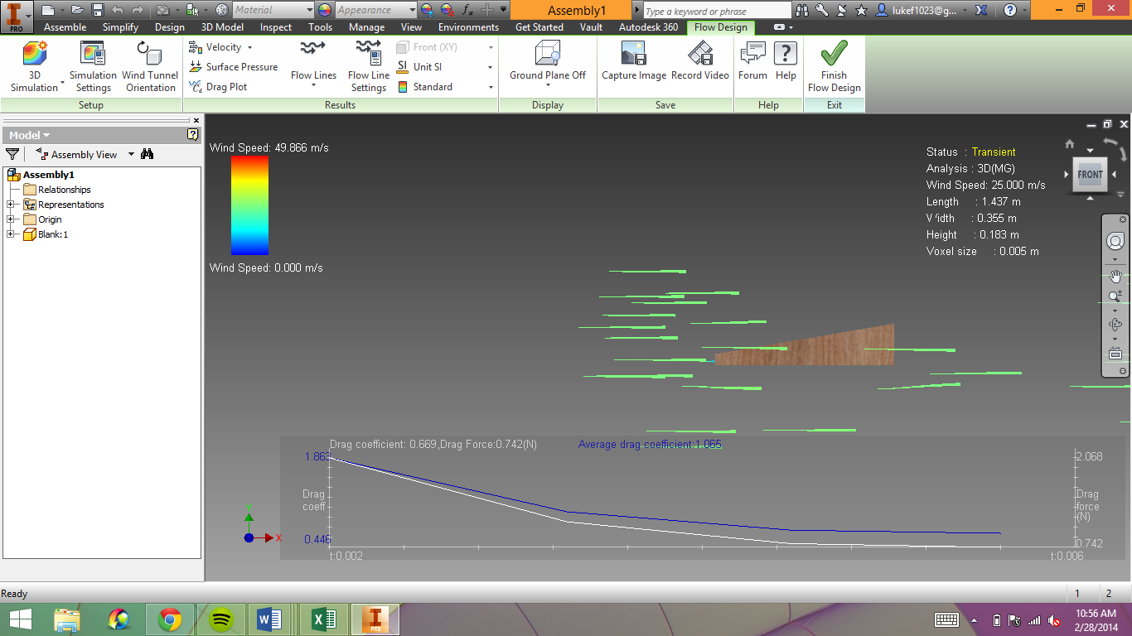

Part | Velocity (m/s) | Avg Cd | Cd | Drag Force (N) | % change Drag force from blank
Blank | 10 | 1.014 | .802 | .14 | ---------------------------
Car without wheels | 10 | .443 | .361 | .06 | .08/.14x100= 57.1%
Car With wheels | 10 | .556 | .431 | .10 | .04/.14x100=28.6%
Blank | 25 (24.9) | 1.065 | .669 | .74 | ---------------------------
Car without wheels | 25 (24.7) | .461 | .395 | .41 | .33/.74x100=44.6%
Car With wheels | 25 | .529 | .427 | .64 | .10/.74x100=13.5%

