Luke Fickenworth
Rodriguez
Intro to Engineering
16 December 2013

Trebuchet Report
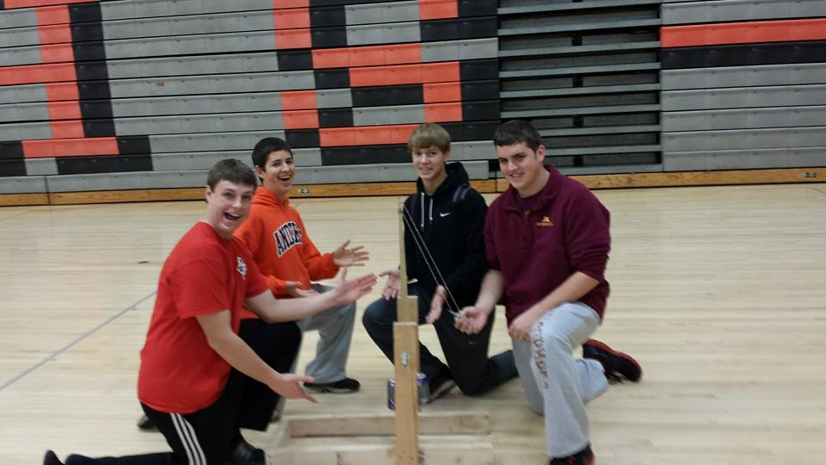
Group members: Luke Fickenworth, Bill Pahutski, Neil Berg, Mark Luke
Our Trebuchet began as nothing more than a couple of pieces of wood and some scrap metal. The end was beyond anything we could have pictured.

Blueprint Drawing
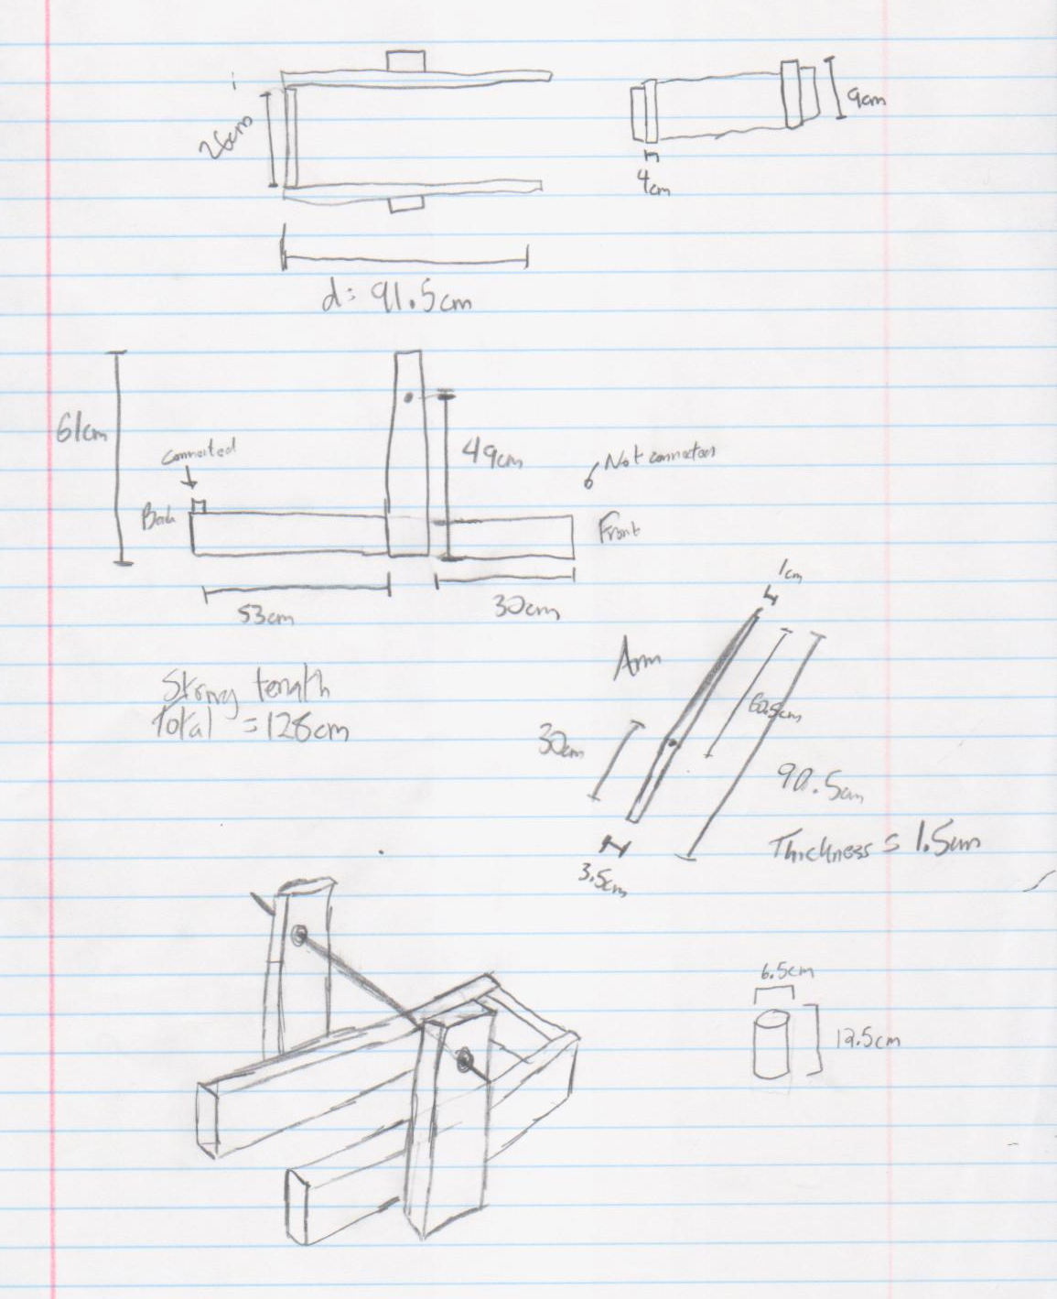

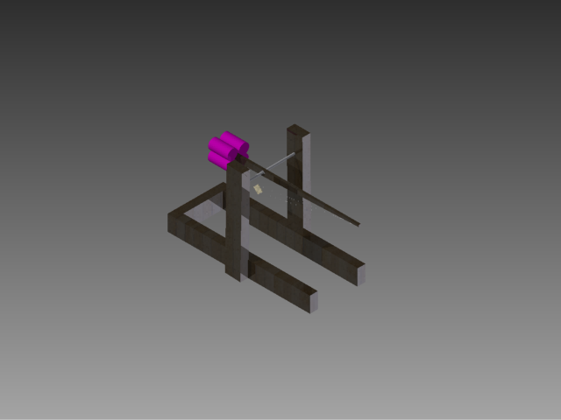

Materials List
- 60 cm. stainless steel threaded rod with a radius of .25 inches
- 150 cm string
- Lacrosse net
- 12, 3 inch screws
- 3 inch copper tubing with a radius of .25 inches
- 4 Grape soda’s- Big K
- 6 half inch bolts and washers
- 8 feet of 2 by 4s- wood

ATREB Software Report
Mass of the counterweight.....M1=1.60 kg
Mass of the missile...........M2=0.02 kg
Mass of the main arm..........M3=0.18 kg
Mass of the CW link...........M4=0.00 kg
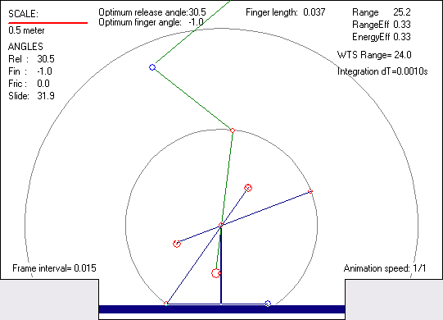
Mass of the sling pouch.......M5=0.00 kg
Mass of the finger assy.......M6=0.00 kg
Mass of the Pivot1 assy.......M7=0.00 kg

Short arm length..............L1=0.30 m
Long arm length..............L2=0.61 m
Sling length..................L3=0.64 m
CW Link length................L4=0.01 m
Main arm support..............L5=0.50 m

Sling mass....................0.000 kg
Sling thickness...............0.0000 m

Analysis mode:................BASIC
Aerodynamics:.................OFF
Friction:.....................OFF
Throwing arm:.................BASIC
Friction in pivot P1:.........N/A
Diameter of pivot P1:.........N/A
Friction in pivot P3:.........N/A
Diameter of pivot P3:.........N/A

Arm width at pivot P1:........0.013 m
Arm width at pivot P2:........0.013 m
Arm width at pivot P3:........0.013 m
Arm height at pivot P1:.......0.026 m
Arm height at pivot P2:.......0.026 m
Arm height at pivot P3:.......0.026 m

Arm density...................604.0 kg/m3
Missile Density...............1500.0 kg/m3

RESULTS OF ANALYSIS
--------------------
Release angle:................30.5 deg
Finger angle:.................-1.0 deg
Slide angle:..................31.9 deg
Friction angle:...............0.0 deg

Max. missile acceleration:....247.2 m/s2
Missile velocity at launch:...15.5 m/s
Trajectory angle (initial):...40.0 deg
Max. tension in the sling:.... 12.7 N

Max. angle of CW:.............152.3 deg
Min. angle of CW:.............-149.6 deg
Max. load in pivot P1:........ 364.3 N

Max.angular vel. of arm:......647.6 deg/s
Max.angular acc. of arm:......40291.8 deg/s2
Max. load in pivot P3:........ 365.8 N

Max. bending moment:.......... 17.5 Nm
Min. bending moment:.......... -11.7 Nm
Max. stress in arm:........... 12.2 MPa
Min. stress in arm:........... -8.2 MPa

Max. transv.load on finger:... 6.3 N
Finger length:................0.04 m

Time of release:..............0.54 s
Flight time (missile):........2.71 s
Range of the throw:...........25.2 m
Range efficiency:.............0.330
Energy efficiency.............0.335

Initial potential energy:..... 8.6 Nm

ADDITIONAL INFORMATION
----------------------
Mass of the arm adjusted:.....NO
Release angle optimized:......YES
Additional Sections used......YES
Rotating CW...................YES
Finger length by..............ATreb
Mass of the finger ring:......0.001 kg
Analysis time step:...........0.001 s

CW propped....................NO
CW prop angle.................N/A
Constraints of arm/CW.........N/A

Building Summary

After we looked at former winning trebuchets, notably the 3rd place group from last year, we decided on our perfect trebuchet. Previous trebuchets were constructed with an open base, made of 2 by 4s, in the shape of an “E” without the middle prong (see left). This would allow for the squash ball to fly from the pouch unimpeded by any support wood from the frame. We decided to use this idea in our own design. Other successful trebuchets had used two pieces of wood, set on a diagonal to form an “A” shape without the connecting middle piece to hold the axle (see right). To us, this seemed excessive. It did give the structure more support, but it didn’t need an incredible amount of support. It only had to launch a 25 gram squash ball and support the 1.8 kg weight of the arm and soda cans used as a counter weight. This doesn’t require a great amount of support, and possibly could provide for a greater possibility of error. So, we decided that the most effective and least amount of risk for the supports of the axle would be one 2 by 4 on each side, standing vertical. We would then drill a hole in the middle of each 2 by 4 for a place to put the axle.
We got started and constructed it as we had planned. However, while drilling holes for the screws, we realized the wood wasn’t of great quality so we had to adjust some screw locations for knots in the wood, so it would sit tightly and not cause cracks and splits in the wood. Never having cut wood with such a high powered saw, it took us some time to get comfortable with using the machine, but the cuts came out crisp and clean when we needed them to.
When designing the axle, we were faced with the problem of finding a material that would cause the least amount of friction but still be stable enough to be accurate. We found a website that helped us in examining which materials caused the most and least amount of friction against others. In the end, we decided on a threaded, stainless steel rod that stretched from one side to another, held in place by two nuts and two washers a side.
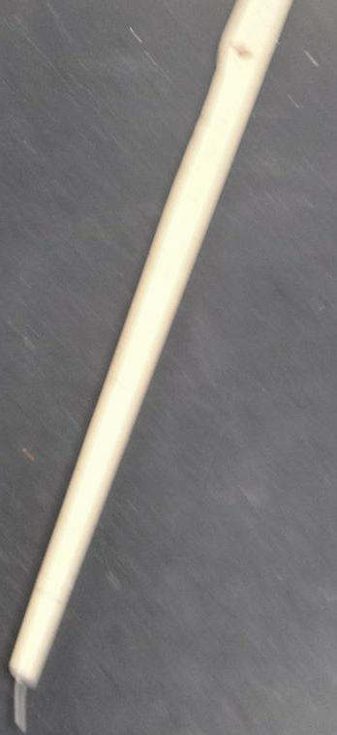
The arm provided us with even more challenges than we had previously thought. We chose to build it out of poplar, which provided us with the sturdiness and lightness we needed. The rules required the arm to be 91 cm or less. We cut it at 92 cm so we could take off more if needed. In the end the wood part of the arm spanned 88 cm. Another rule required the arm to be heavier on the throwing side when the counterweight was removed. So we had to shave off weight from the throwing arm. This took quite a lot of time in measuring, calculating, and cutting precisely. The hole for the axle was drilled 58 cm from the end of the throwing arm side. This means that it was approximately 14 cm off center, which we found to be the best location thanks to ATREB software we used. The end of the throwing arm side ended in a 2.5 cm nail that protruded straight out, and we would later change the angle of depending on the flight of our squash ball.
The hole of the arm, which was around the axle, had to be adjusted to find the perfect diameter to fit the axle. But, the poplar on the stainless steel was not the best for minimizing friction, so we had to change our design. We inserted a small piece of copper into the hole in the wood. This fit snuggly into the wood but we glued it in to be safe. The copper on the stainless steel had much less friction than any other two materials we had access to. This small amount of friction aided in the trebuchet’s throwing distance. To hold the arm in place, we attached two washers and two nuts on either side that could be tightened and loosened to provide ideal throws.
Using the allowed 30 cm of tape, we attached four grape soda cans to the end of the arm to act as the counter weight. This originally did not hold the cans in place, so we put a nail at the end of the arm to make sure they were secure and would not fall off.
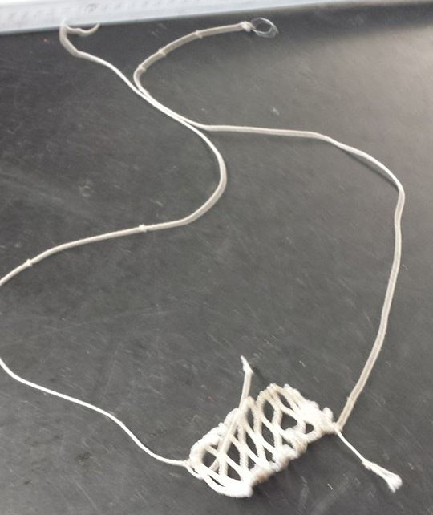
Originally, for our sling we had used an old, elastic book cover for, but after several failures, we changed our direction to the lacrosse netting, which allowed us to securely hold the ball in place, and still throw the ball at a 45 degree angle.
On the end of the throwing arm, a 2.5 cm nail stuck out, which was where we hooked one part of our sling on. This nail was adjusted as we saw fit, so as to launch the ball at a 45 degree angle and maximize total distance thrown. The other side of the string was taped to the end of the arm. This way, when the ball was released, one end of the string would release, flinging the ball forward.
If we had been given more time, we feel we could have improved our design to maximize distance and accuracy. Our accuracy was inconsistent. Occasionally it would land within centimeters of our target, and others it would be up to half a meter away. Given more time, we could have evaluated the cause of the lack in accuracy and fixed it. We had also planned to grease the axle so as to reduce friction more, but time was working against us.
Overall, our trebuchet turned out better than we had ever thought it could have turned out. We were very pleased with its performance and learned a lot about carpentry, physics, and teamwork through this project.

Test Results
Our trebuchet performed very well in competition. We achieved a maximum distance of 54.5 feet. Our average distance from the target was 40.5 inches. But both these numbers were much worse had we not tested it, and improved from our original design.
Finger angle from end of wood | Distance (feet)
90 | 30
85 | 39
80 | 47
70 | 48
60 | 46
75 | 53

As shown in the data, the ideal angle of the finger nail was 75 degrees from the end of the arm. This let the hook of the string slide off at a better angle, throwing the ball farther than any other angle. Using this angle, we tested trebuchet shots by pulling the pouch back to different distances; not making the string taut and marking the distances on the wood for each trial. This helped us predict our distance and establishing accurate shots.
Distance pouch was pulled from the maximum distance. (cm) | Distance  (feet)
0 | 52
2 | 50
5 | 46
8 | 44
12 | 42
15 | 38

This information helped us in competition to hit the targets that were laid out on the gym floor.
The ATREB software told us the optimal string length was 64 cm. We used this and achieved good results, so we kept it at this length.
For the actual competition we threw for distances of 54.5 feet, 49 feet, 51.5 feet, and 52 feet. Our distances away from the target were 12 inches, 56 inches, 60 inches, and 34 inches. This led to an average of 40.5 cm away from the target. While we had hoped for better results, we accepted our above average distance but inconsistent accuracy.

