Tutorial: LabVIEW Basics Name _______Luke Fickenworth______

Start LabView for Education 2010. On the bottom of the “Getting Started” screen, there is a “Teach Me” link. Click there a “Basic LabView” tutorial. Be sure to save your *.VI files for each tutorial and project!!
1)Pythagorean Theorem
SQRT(a² + b²) =c

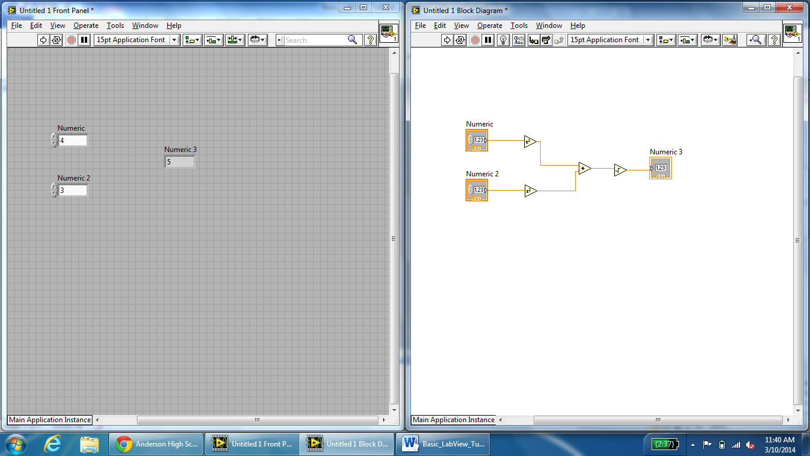

2) Your First LabVIEW Program
Result= ( Numeric1+Numeric2) X (Numeric3-Numeric4)
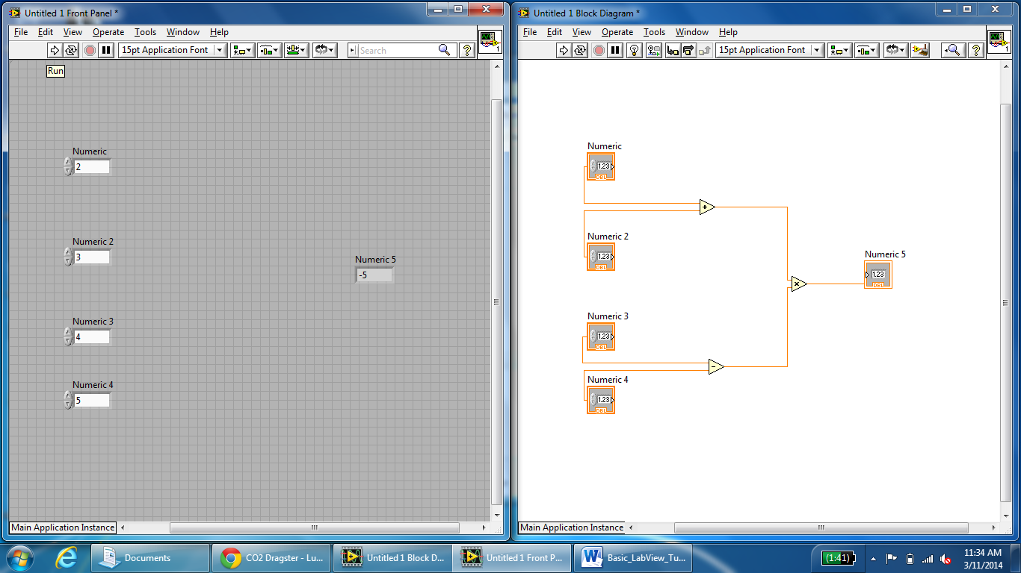

3) Your Second LabVIEW Program
Y= (4x² – 5)/(x-2)
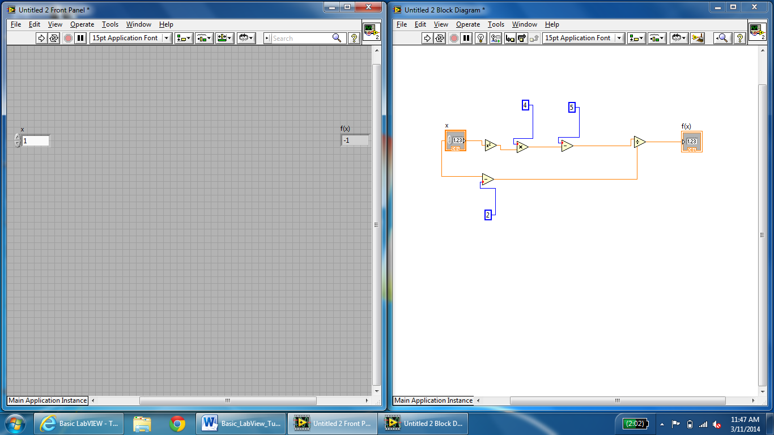

4) Monthly Loan Calculator
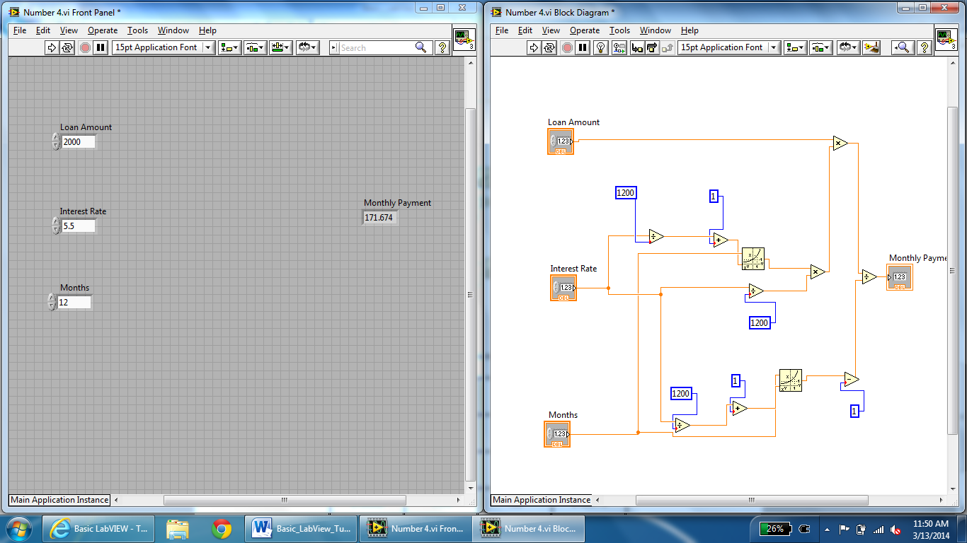
5) Case Structures
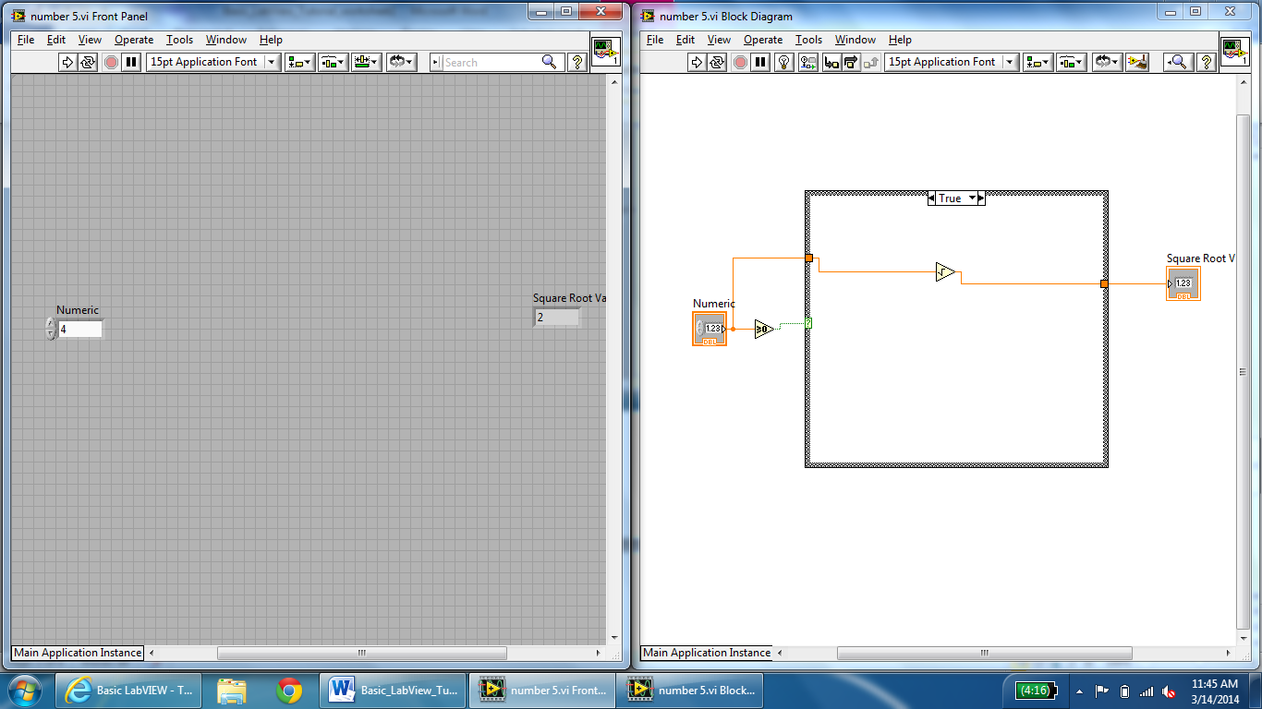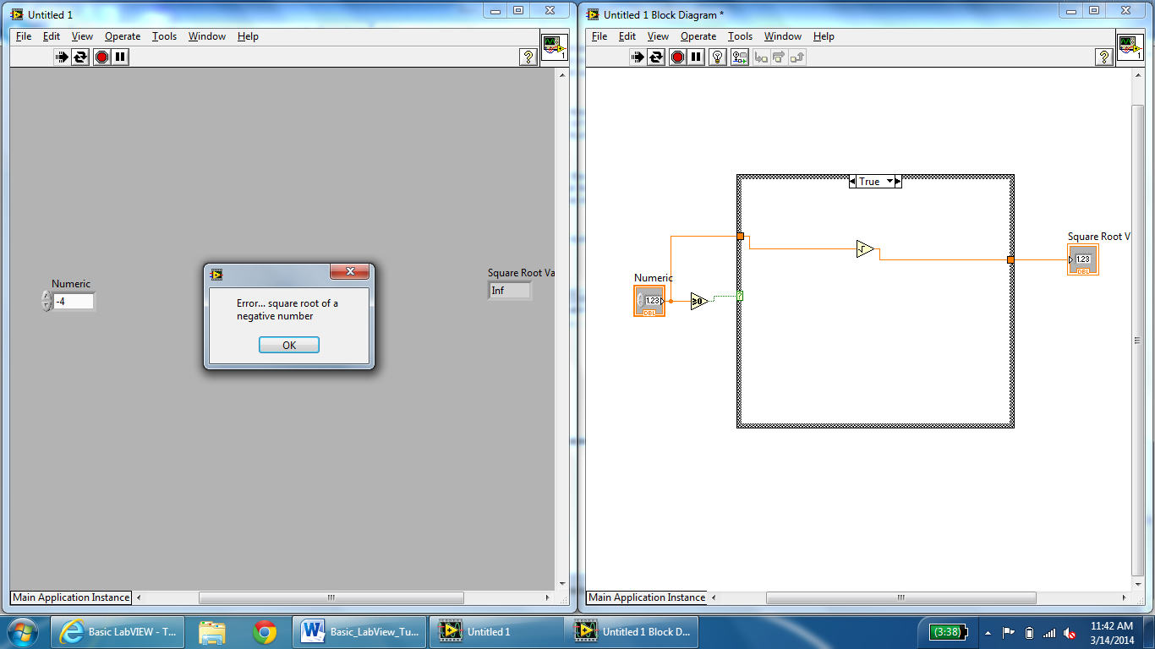

6) LabVIEW While Loops
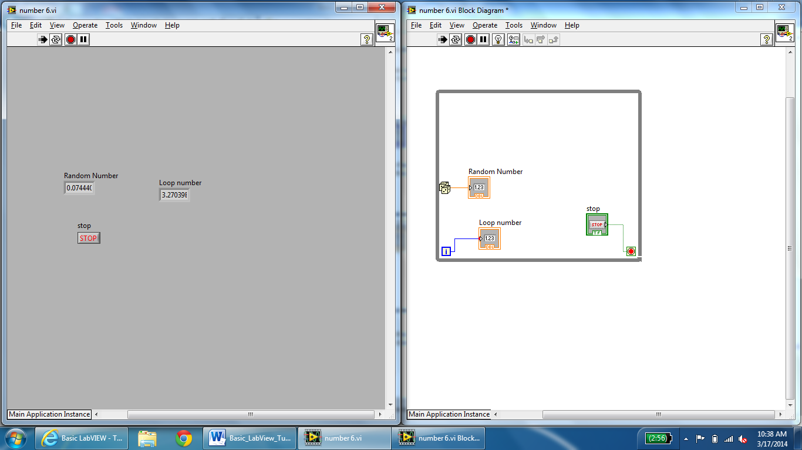

7) For Loops
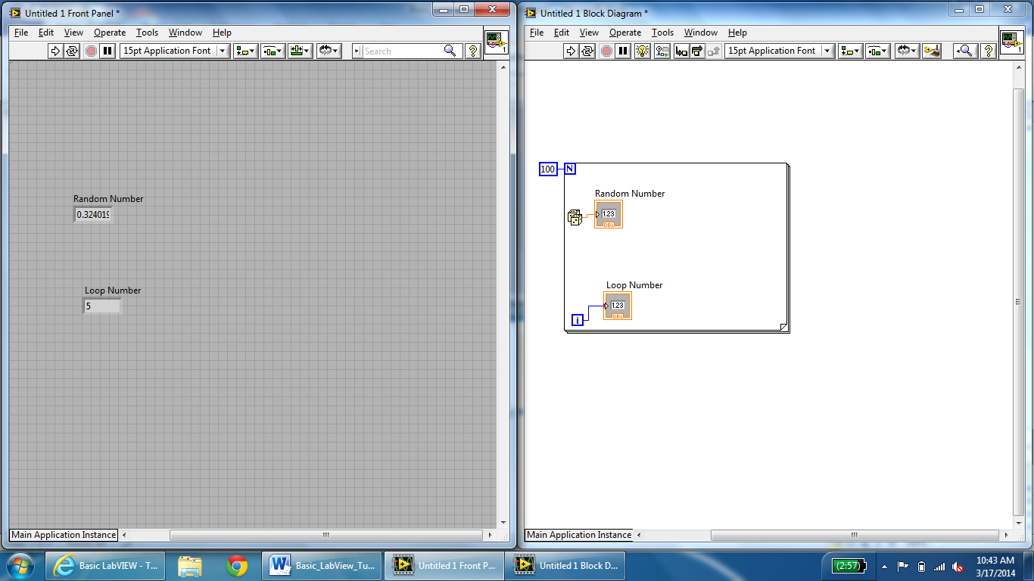

8) Shift Registers
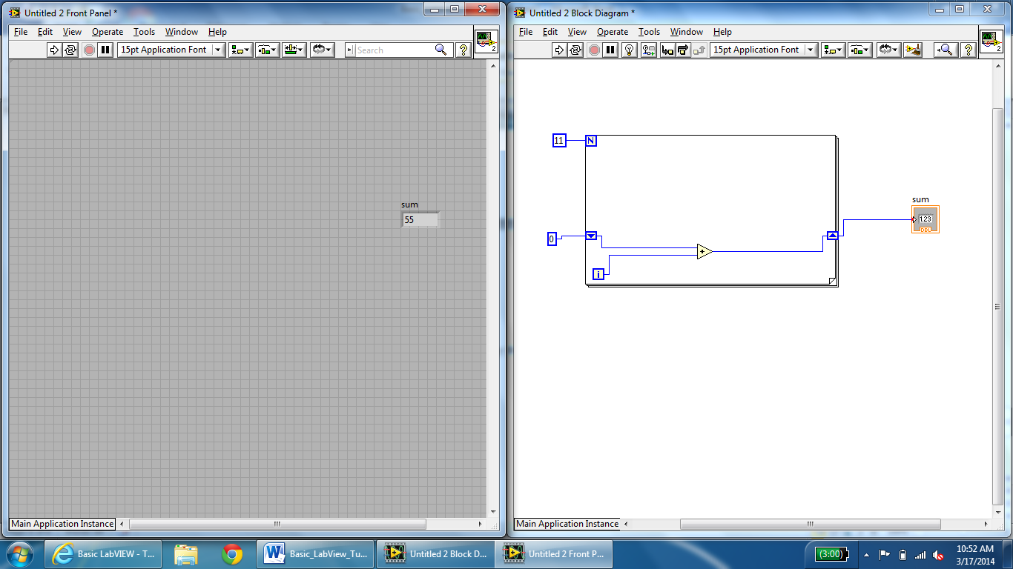

9) Square Root Calculator Project
